Experiment no-13
Online Flower and Gift Shopping
AIM:
To develop an online flower and gift shopping website with product categories and selection options.
PROCEDURE:
- Create a webpage with flower and gift categories.
- Display available products and prices.
- Add buttons to select products and add them to the cart.
- Display the selected product and its price.
- Run the webpage in a browser.
Sample Code:
<!DOCTYPE html>
<html>
<head>
<title>BlossomGifts</title>
</head>
<body>
<h2>BlossomGifts</h2>
<select id="gift">
<option value="200">Rose Bouquet - ₹200</option>
<option value="500">Gift Basket - ₹500</option>
<option value="300">Chocolate Box - ₹300</option>
</select>
<button onclick="addGift()">Add to Cart</button>
<p id="out"></p>
<script>
function addGift() {
let gift = document.getElementById("gift");
document.getElementById("out").innerText =
gift.options[gift.selectedIndex].text +
" added to cart. Price: ₹" + gift.value;
}
</script>
</body>
</html>S
Sample Output:
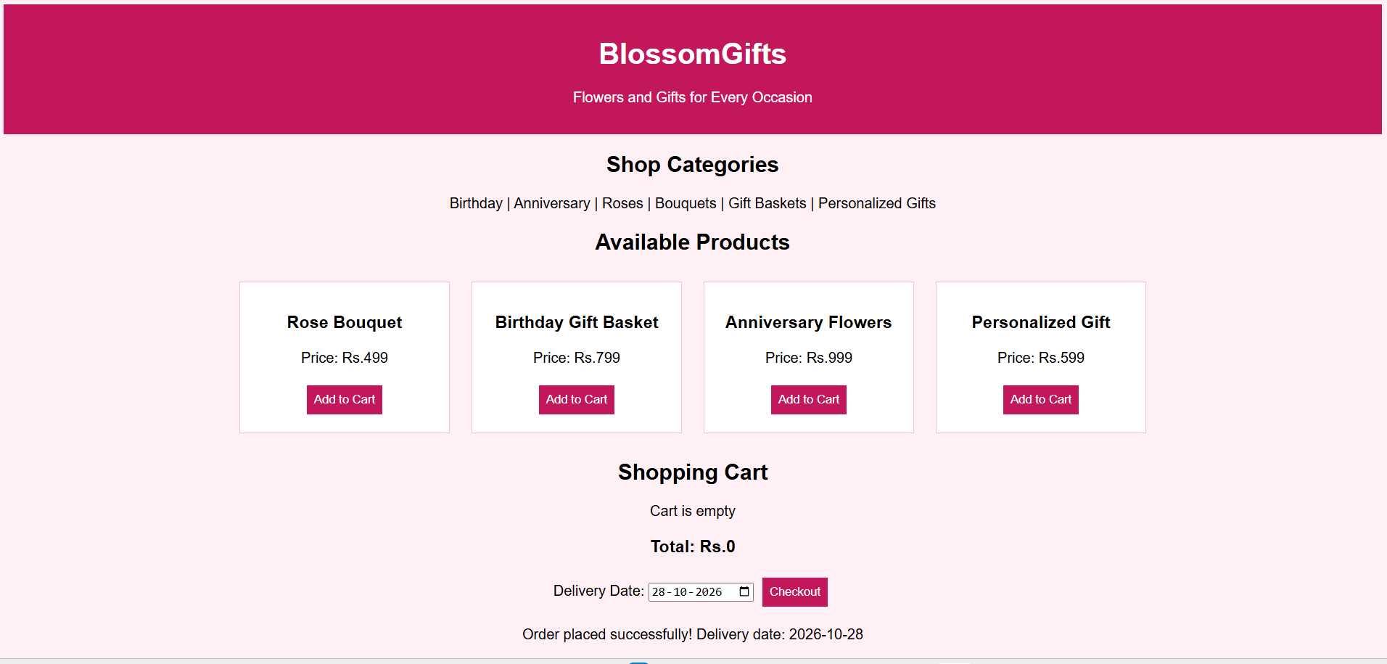
Result:
The Blossom Gifts webpage was created successfully with gift selection and cart functionality.

